 Introduction to Transaction Rules
Observation Exercise

Create a Transaction Pre-setup rule called "Test Rule". Deactivate the rule. Then, follow the instructions and answer the questions. (For each question, you can retain or delete the code from the previous question.)

1. Paste the following line of code into the Rule Actions window. Is it syntactically well-formed? If not, what would you need to change to fix it? (Use the Studio syntax checker for hints.)
// Set TotalAmount to total amount of transaction set
var TotalAmount = transaction.ClaimAmount

2. Paste the following line of code into the Rule Actions window. Is it syntactically well-formed? If not, what would you need to change to fix it? (Use the Studio syntax checker for hints.)
// Set NumberOfReserveTransactions to the number of reserve transactions
var NumberOfReserveTransactions = transactionSet.Reserves.length

3. Paste the following lines of code into the Rule Actions window. Is it syntactically well-formed? If not, what would you need to change to fix it? (Use the Studio syntax checker for hints.)
// Create ExceedsAvailableReserves. Set it to whether payments exceed reserves.
var ExceedsAvailableReserves : boolean
ExceedsAvailableReserves = transactionSet.ExceedsAvailableReserves

4. Paste the following lines of code into the Rule Actions window. There are three syntactic errors. Correct the errors. (The comments describe what the code should do. Use the Studio syntax checker for hints.)
// For each transaction in transaction set, set amount equal to
// transaction amount. Then, if transaction is reserve transaction
// for reserve with Cost Category "salvage", add a note to the claim
for (txn in transactionSet.Transactions)
{
var amount = Transaction
if (txn.CostCategory == "salvage" AND txn is "Reserve")
{
txn.Claim.addNote( "salvage", "Salvage reserve created for " + amount )
}
next txn
}

Configuration Exercise

Configure ClaimCenter to meet the following customer requirement from Acme Insurance.

Requirement 1: Recording Reserves in Notes

At Acme Insurance, the current claims processing system writes a "record of note" every time a reserve transaction is created. It captures the cost type, cost category and the total amount of the reserve transaction. Even though this information appears on the Transaction lists on the Financials screen, Acme Insurance wants to ease the transition to the new system by mimicking the "record of note" behavior in the old system.

5. Write a transaction rule that creates a note every time a reserve transaction is created. The note topic should be "general". The subject line should read "<Cost type> Reserve Transaction". The Related To field should be populated with the appropriate exposure. The note body should read "<CostCategory> reserve transaction for $<TransactionAmount> created." This rule should be executed only when the transaction is created, and not every time the transaction is modified.
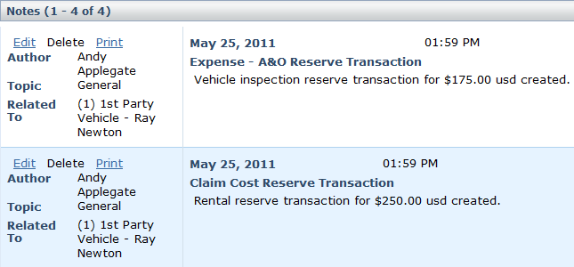

6. The ClaimCenter implementation team has provided additional notes:
- In order to meet Acme's requirements, you must use the Reserve entity's TransactionAmount field for the note text.
- Since you are writing a note once the transaction has been setup (and not modifying the transaction) you should create this rule in a Post Setup ruleset.

Test Cases: Requirement 1

When you have completed your configuration, run the following test case:

7. Navigate to a claim with an existing exposure. Create two or move reserve lines against the exposure. Verify that notes are added to the claim for each reserve transaction.

Requirement 2: Payment Matching Reserve Fraud Detection

Acme Insurance has identified that a common approach to claim fraud involves a disreputable employee who opens a claim, sets a reserve, and then makes a payment which is equal to the reserve amount. Acme wants an activity to get created for SIU review whenever this occurs.

8. Create a transaction rule that creates a Special Investigation Claim Review activity whenever the amount of a check set equals the remaining reserves on the claim. This rule should be executed every time a transaction is created and should be generated whether the transaction is approved or not.

9. The ClaimCenter implementation team has provided additional note:
- You can use the "SI_review" activity pattern. You do not need to worry about how the activity gets assigned.

Test Cases: Requirement 2

When you have completed your configuration, run the following test case:

10. Create a new auto claim using the quick claim wizard. Once you have created the claim, create a Towing and Labor exposure for it. Then, create a reserve line of $1000.

11. Verify that the claim and its exposure are at Ability to Pay. If they are not, bring them up to Ability to Pay.

12. Create a check that equals the reserve line ($1000).
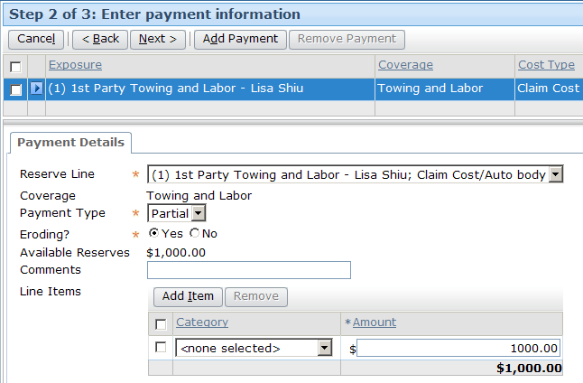

13. Once you have completed the Payment Wizard, check the claim's workplan. There should be a Special Investigation Claim Review activity in the workplan.
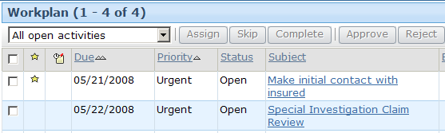

Requirement 3: Assistance with Matter Creation

Complete this requirement only if your instructor tells you to do so.

In the past, Acme Insurance has experienced delays in claims processing because of confusion around litigation. Reserves get created with a cost type of "Expense - D&CC" (which is for defense and cost containment), but a matter doesn't get created to track the legal issues. To help limit this confusion, Acme wants to create an activity whenever a reserve line is created of type "Expense - D&CC" but where no matter exists.

14. Create a transaction rule that creates an activity whenever a reserve transaction is created for an exposure of type "Expense - D&CC" on a claim that has no matters. The activity should be associated with the transaction's exposure. This rule should be executed only when the transaction is created, and not every time the transaction is modified.

15. The ClaimCenter implementation team has provided additional notes:
- You can use the "legal_review" activity pattern. You do not need to worry about how the activity gets assigned.
- Every array in GScript has a .length attribute which equals the number of elements in the array.

Test Cases: Requirement 3

When you have completed your configuration, run the following test case:

16. Navigate to a claim with no legal review activities and no matters. (Both of these can be verified from the claim's Summary screen. Matters are listed in the Litigation list.) Then, create a reserve transaction with a cost type of "Expense - D&CC". Finally, verify that a legal review activity was created and associated to the exposure.

